**Lambda service**

* **What is AWS lambda service?**
* **AWS Lambda** is a **serverless compute service** offered by Amazon Web Services (AWS).
* In this you can **run your code without provisioning or managing servers**.
* You simply write your function, define a trigger, and AWS takes care of the rest—scaling, availability, and infrastructure management.
* **How it works**

1. **You write code** as a function (in Python, Node.js, Java, Go, etc.).
2. **Upload it** to AWS Lambda or write directly in the AWS Console.
3. **Set a trigger**, like:
   * File upload to S3
   * HTTP request via API Gateway
   * Message in SQS/SNS
   * Scheduled time .
4. **Lambda executes** your function automatically when the trigger occurs.
5. **Logs and metrics** are stored in Amazon CloudWatch.

* Lab Steps:

**🔹 Step 1: Sign In to AWS Console**

* Go to: AWS console.
* Sign in with your AWS account.

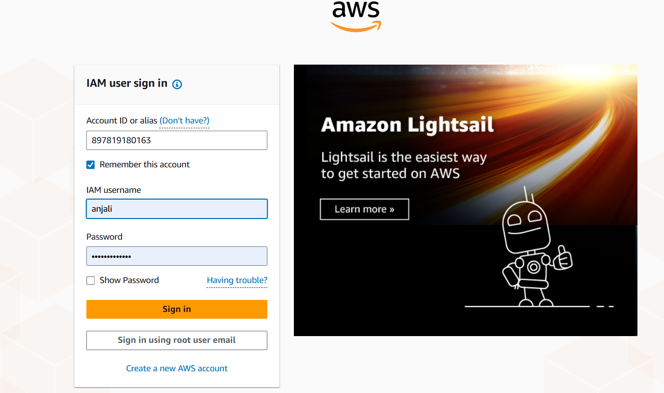

**🔹 Step 2: Navigate to Lambda Service**

* In the **AWS Management Console**, search for “**Lambda**” in the top search bar.
* Click on **Lambda** under **Services**.

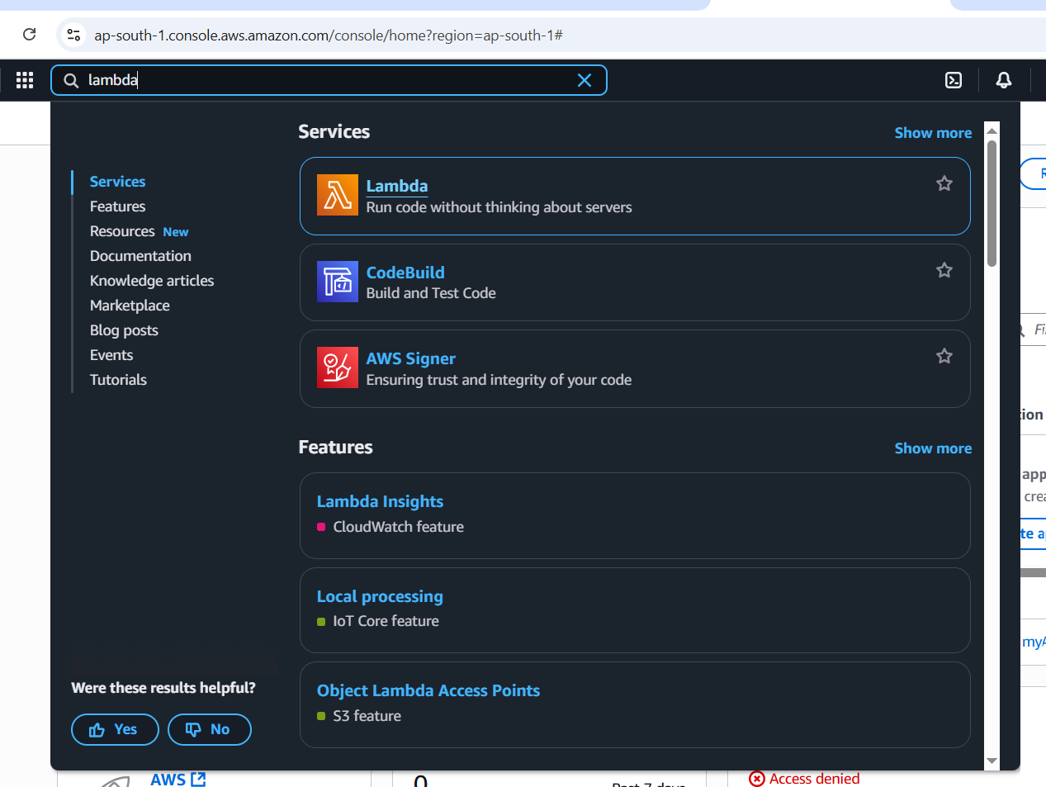

**🔹 Step 3: Create a Lambda Function**

1. Click **“Create function”**.

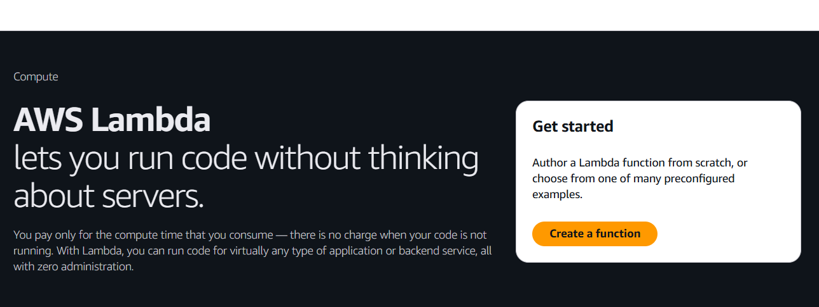

1. Choose **Author from scratch**.

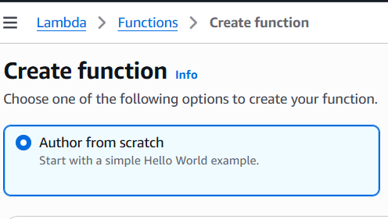

1. Fill in the details:
   * **Function name:** demofunction

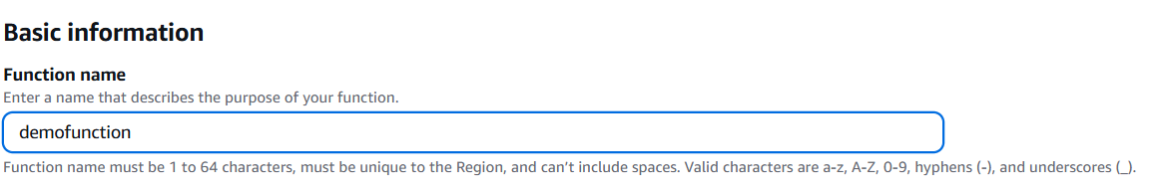

* + **Runtime:** Choose (e.g., Python 3.12, Node.js 18.x, etc.)

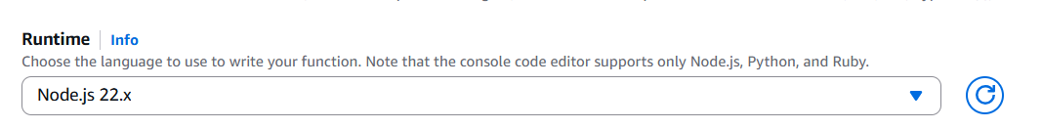

1. Choose or create an **Execution Role**:
   * Let AWS create a new role with basic Lambda permissions (default for beginners).
2. Click **“Create function**

🔹 **Step 4: Write or Upload Your Code**

* In the **Function code** editor:
  + You can write code directly in the console or upload a .zip or container image.
* Example (Python):

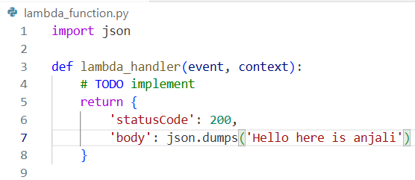

* Click on **Deploy** to save the code.

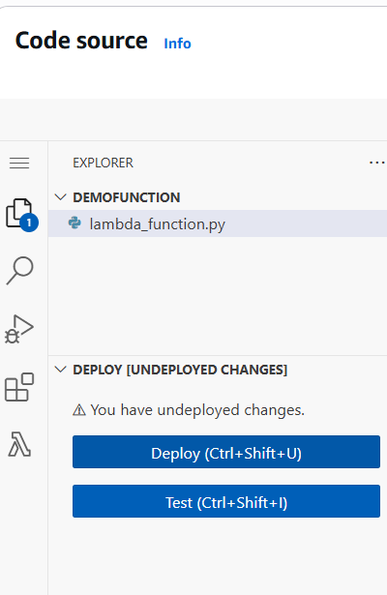

**Step 5: Add a Trigger (Optional, e.g., API Gateway or S3)**

1. Scroll to **Function overview**.
2. Click **+ Add trigger**.
3. Choose an event source, such as:
   * **API Gateway** (for REST APIs)
   * **S3** (for file upload)
   * **CloudWatch Events** (for scheduled tasks)
4. Configure the trigger settings.
5. Click **Add**.

**🔹 Step 6: Test the Lambda Function**

1. Click **Test** at the top. 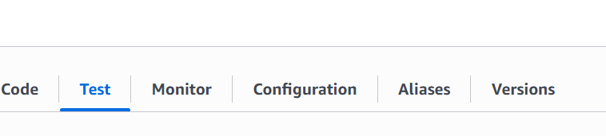
2. Create a new test event:
   * Choose **“Create new event”**.
   * Give it a name, and use a sample payload or leave as default.
3. Click **Test** again to invoke the function. 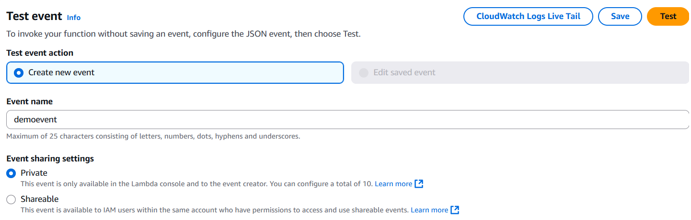

* You should see output in the console under **Execution result**.

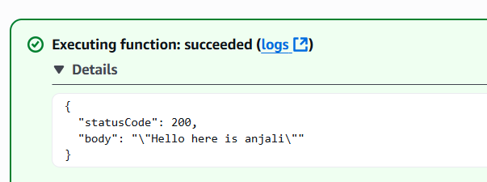

**🔹 Step 7: Monitor and Logs**

* Go to the **Monitor** tab to view metrics (invocations, duration, errors).

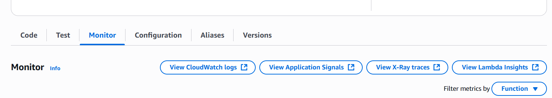

* Click **View logs in CloudWatch** to see detailed logs.

**🔹 Step 8: Modify, Version, or Delete**

* You can:
  + Add environment variables
  + Set concurrency and memory limits
  + Create **aliases** and **versions** of your function
  + Delete the function when done

